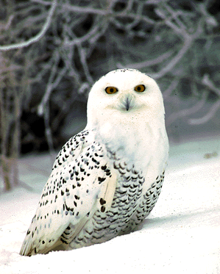
OKPIK Cold Weather Camping Training
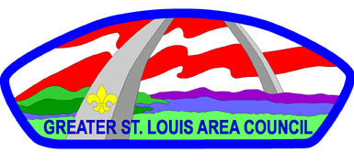
Scoutmaster’s/Advisor’s Approval
Scoutmaster/Advisor: The unique winter camping skills delivered in the GSLAC Okpik Training program are provided within a managed environment and culminates in a 24-hour outdoor overnight session. While this is NOT a survival course, winter camping does have inherent risks. Cold weather can be dangerous and demands adherence to best practices to mitigate injuries. Scouts and Scouters are placed in patrols that may or may not include other participants from unfamiliar districts or units. Unit leaders are asked to assess the functional and social skills demanded by this type of activity, in addition to confirming the eligibility of the youth participants from their unit. There are four troop meetings – it is mandatory that all participants attend each of the sessions in their entirety in order to receive a graduation package and credit for the course. Youth are required to present this Scoutmaster’s/Advisor’s Approval at registration.
Thank you!

(Print Scout’s name)_______________________________________________________________________________________________________________________

I approve the above-named Scout for attendance at the upcoming Okpik Cold Weather Camping Training session.

(Scoutmaster/Advisor Signature)________________________________________________________________________________________________________

(Please print your name here)___________________________________________________________________________________________________________

Contact Phone #_____________________________________________Email:_______________________________________________________________________

Troop/Crew # ________________________________________________Date:________________________________________________________________________

