Greater St. Louis Area Council Boy Scouts of America
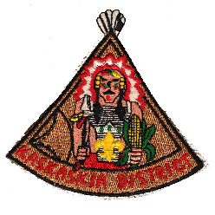SPECIAL ACHIEVER SPARK PLUG AWARD
KASKASKIA DISTRICT
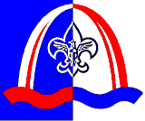
This award is for adult members of the BSA whose spirited contributions are generally not recognized outside the nominee’s unit, though district or higher service can be considered.
REQUIREMENTS
The nominee shall have been a registered adult member of the BSA for the entire year. The nominee shall have completed the required training for the primary position in which they serve.
OTHER FACTORS FOR CONSIDERATION
______ Attends Roundtables _______ Active in District and/or Council
This is the person who always helps (with a smile); makes one feel good by just being around them; picks one’s spirits up; and recharges one’s battery!
All of the above requirements have been considered and I hereby nominate:
NAME (print) ___________________________________________________ UNIT# ________
ADDRESS ____________________________________________________________________
CITY/TOWN __________________________________________ PHONE ________________ Basis of nomination (include examples)
Other noteworthy service in their community: (Example – PTA, Church, Rotary)
**********************************************
NOMINATOR _______________________________________________ DATE ____________
PHONE ______________________ SCOUTING POSITION / UNIT________________/_____
2014 Revision If needed, use back of form or attach additional information

