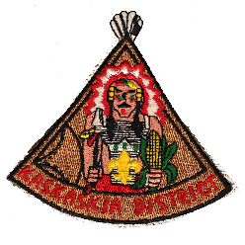
KASKASKIA DISTRICT
DEN LEADER OF THE YEAR
REQUIREMENTS
The nominee shall have served (registered) as a Wolf and/or Bear Den Leader for a minimum of 8 months during the year. The nominee shall have completed required training for the position.
OTHER FACTORS FOR CONSIDERATION
______ Attends Roundtables _________ Active in District and/or Council
______ Participated in Day Camp ______ Years served as an adult leader
______ Den and/or Pack has participated in the Summertime Pack Award
All of the above requirements have been considered and I hereby nominate:
NAME (print) ________________________________________ UNIT# ________ ADDRESS ______________________________ _________________________ CITY/TOWN _______________________________ PHONE ________________ Basis of nomination (include examples and advance training participated)
Other noteworthy service in their community: (Example – PTA, Church, Rotary)
NOMINATOR DATE
PHONE ________________ SCOUTING POSITION /UNIT_____________/_________

2014 Revision If needed, use back of form or attach additional information
Greater St. Louis Area Council Boy Scouts of America

