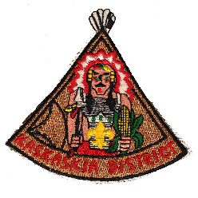
KASKASKIA DISTRICT
CUBMASTER OF THE YEAR
The nominee shall have served (registered) as Cubmaster for a minimum of 8 months during the year. The nominee shall have completed required training for the position.
OTHER FACTORS FOR CONSIDERATION
______ Attends Roundtables _______ Active in District and/or Council
______ Participated in Day Camp, Years served as a Cubmaster, ______ Pack has participated in the Summertime Pack Award, ______ Pack achieved Gold / Silver / Bronze JTE Unit status (circle level) during year
All of the above requirements have been considered and I hereby nominate:
NAME (print) __________________________________________ UNIT# ________ ADDRESS ___________________________________________________________________ CITY/TOWN _________________________________________ PHONE ________________
Basis of nomination (include examples and advance training participated)

Other noteworthy service in their community: (Example – PTA, Church, Rotary)
***********************
NOMINATOR _____________________________________________ DATE ____________
PHONE _____________________ SCOUTING POSITION / UNIT________________/_____

2014 Revision If needed, use back of form or attach additional information
Greater St. Louis Area Council Boy Scouts of America

